Curriculum Vitae 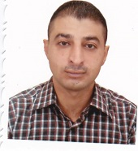
Name: Dr. Yahyia Majeed Hameed
Adress: Diyala / Al-Khalis
Date of birth: 4/11/1980
Gender: Male
Education Qualifications:
1- Ph.D. Civil Engineering (Structures)
2- Ms.C. Civil Engineering (Structures)
3- B.Sc. Civil Engineering
Language: Arabic-English
Experience in computer: ANSYS, Microsoft office, Visio
Academic experience:
Teaching in the Department of Civil Engineering at the University of Diyala since 2006

